**Name: Maskeen Singh**

**Roll no: 06**

**Practical 06**

**Aim: Working with Regular Expressions.**

**1)re.findall()**

**\d** Matches any decimal digit; this is equivalent to the class[0-9].

+1 or more occurrences of the pattern to its left

**Code:**

import re

string ="hello 09 hii 30.Howdy 34"

pattern='\d+'

result=re.findall(pattern, string)

print(result)

**Output:**

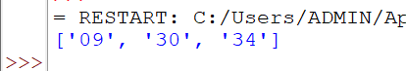

**2)re.split()**

**Code:**

import re

string ="Twelve:12 Eighty nine:89"

pattern='\d+'

result=re.split(pattern, string)

print(result)

**Output:**

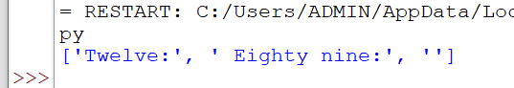

**3)re.sub()**

The method returns a string where matched occurrences are replaced with the code variable.

**\s** Matches any whitespace character.

**Code:**

import re

string='abc 12\de 23\n f45 6'

pattern='\s+'

replace=""

new_string=re.sub(pattern, replace, string)

print(new_string)

**Output:**

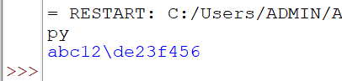

**4)re.search()**

If the search is successful, re.search() returns a match object; if not, it returns None.

**Code:**

import re

string="Python is fun"

match=re.search('\APython', string)

if match:

print("pattern found inside the string")

else:

print("pattern not found")

**Output:**

